**Delete Timeline**

Preconditions: 1) Delete mode has been chosen.

Description: The user chooses to delete a timeline and remove all the information about this timeline (Start and end time, title and description).

Exceptions: Display mode does not give you the option to edit or create an event.

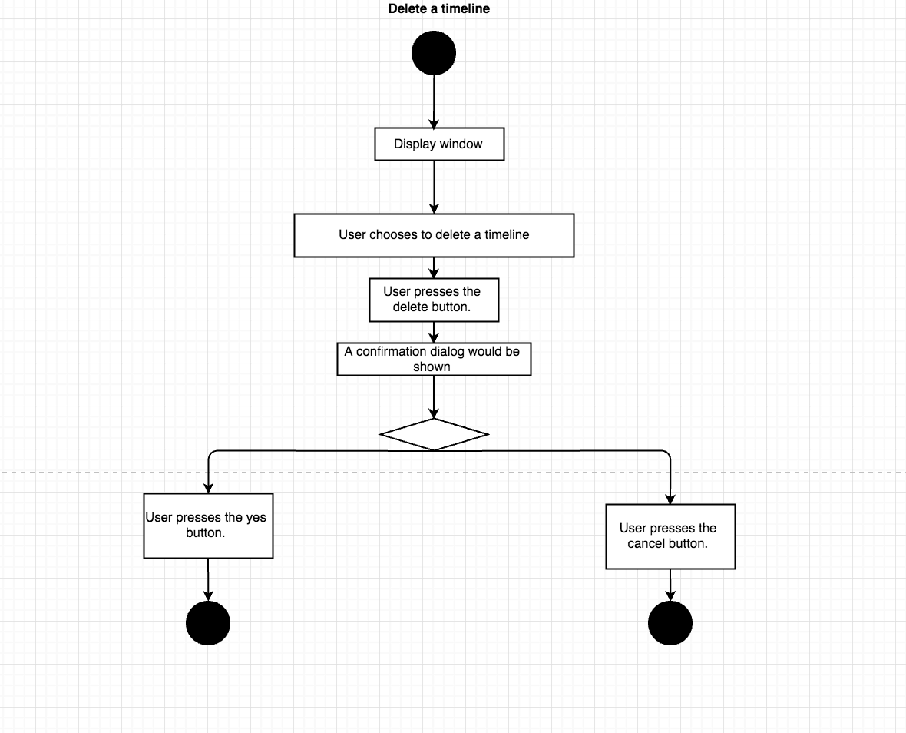

**Add event without duration**

Preconditions: 1) Create mode has been chosen. 2) Timeline has been created. 3) The option to add an event without duration has been chosen.

Description: The user chooses a title, picture(optional) and description for the event.

Exceptions: Display mode does not give you the option to edit or create an event.

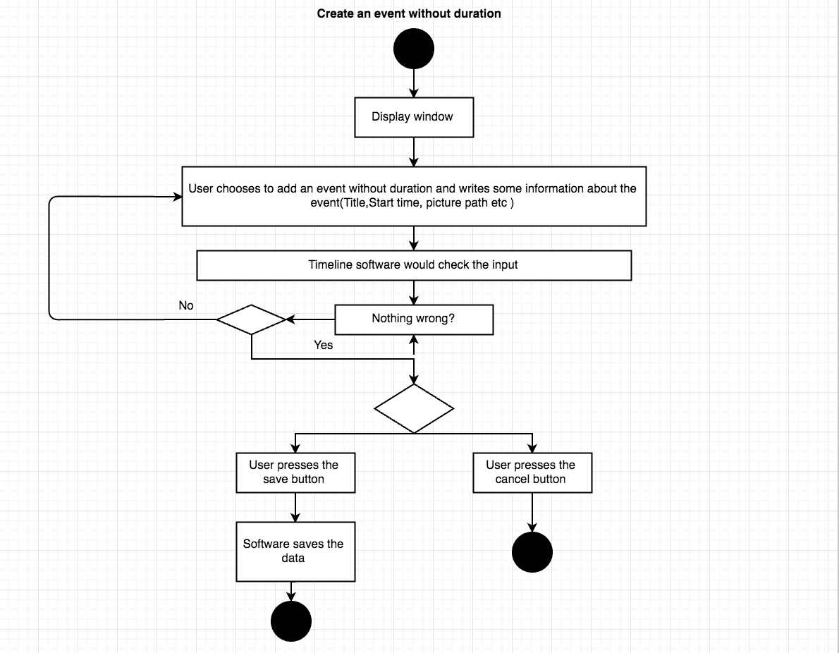

**Delete event**

Preconditions: 1) Delete mode has been chosen.

Description: The user chooses to delete an event and remove all the information about this event.

Exceptions: Display mode does not give you the option to edit or create an event.

